A User’s Guide

to

Networked Checkers

Developed by Team One

Logan Ayer

Matthew Bauer

James Muoghalu

Luke Weaver

The Game Client

When you first run the game client, you will see the screen below:

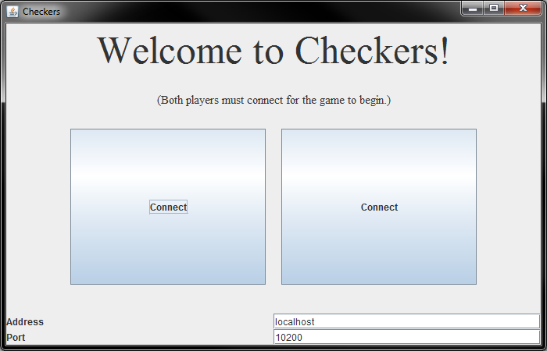

* The first area to note is labeled **Address**. This is referring to the server you wish to connect to. If you yourself are hosting the server, “localhost” is what you are looking for.
* The next area we want to check is labeled **Port**. This refers also to the server and corresponds to the network port in which the server will look for players.
* Finally, we are ready to click one of the connect buttons (either will do)!

After clicking a connect button, you will see one of the screens below:

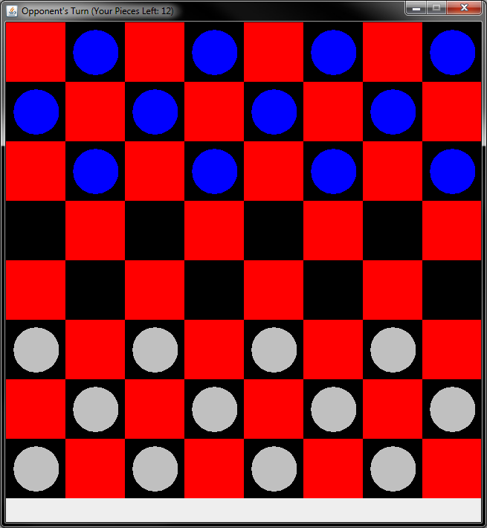 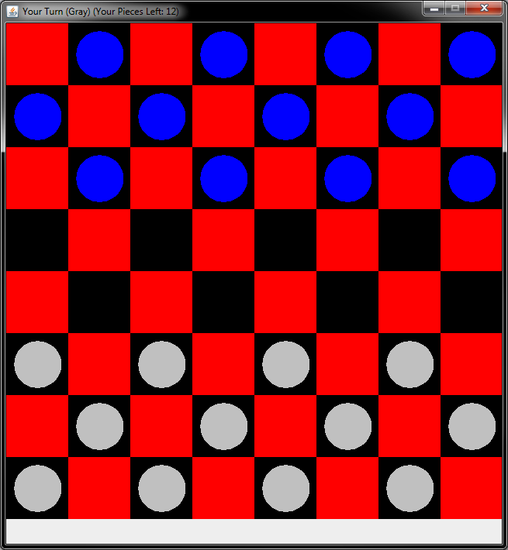

* In the top left, you will see a message telling you whose turn it is. You will also see the number of pieces you currently have at your disposal.
* To make a move, you should hover over one of your pieces and select the piece you wish to move. When hovering, you should see your piece highlighted as illustrated below:

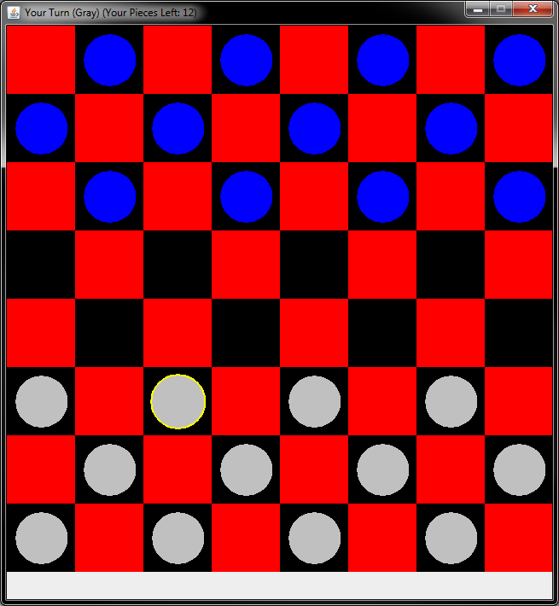

* Once you click a piece, your available moves will be shown in blue as illustrated below. Also note that when a jump is available, the square is also highlighted.

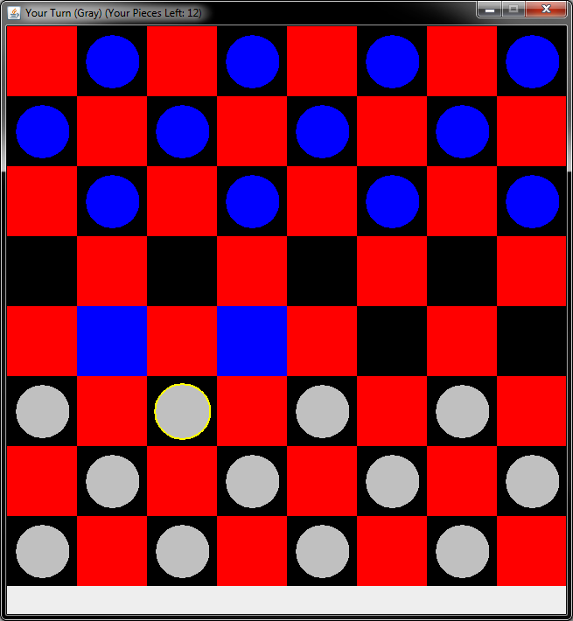 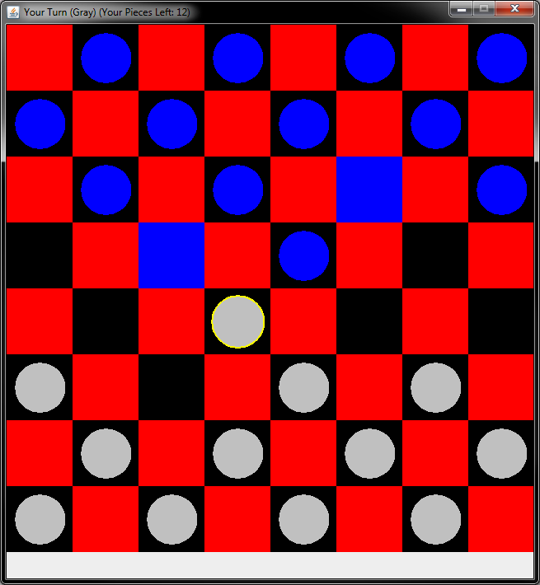

* Clicking a blue square simply moves your piece to the selected spot while taking away opponent’s pieces if a jump occurred.
* The images below show a potential double jump. After taking the first jump, another blue square appears for a second jump! You are given the option to not take this jump.

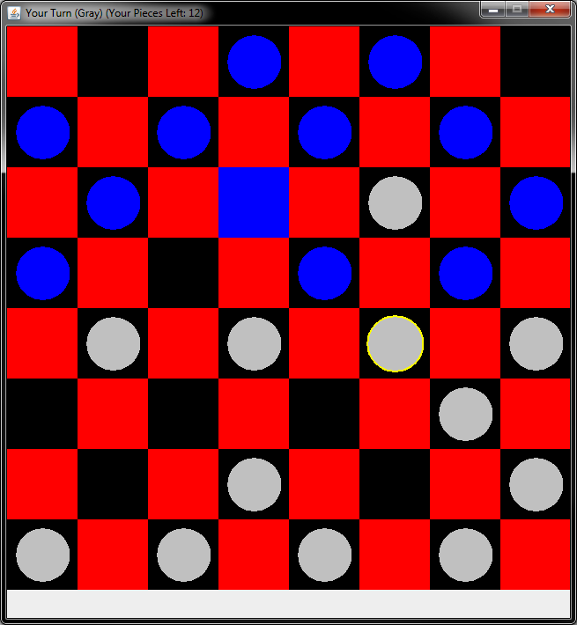 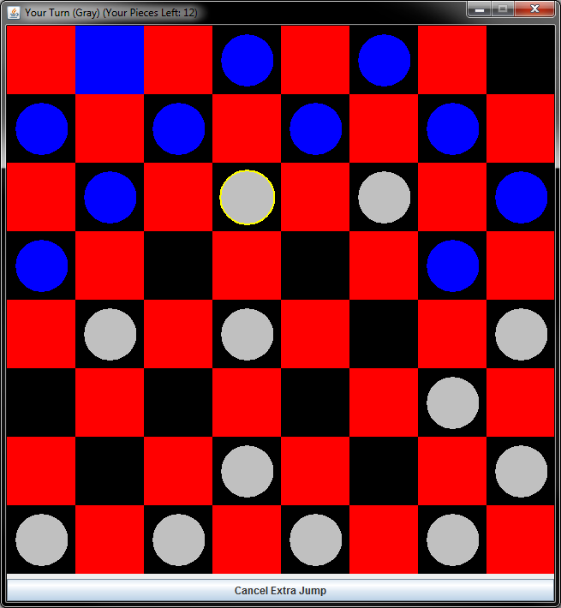

* When a piece reaches the opposite side of the board, it is then upgraded to be a king! King pieces behave like normal pieces except that they can move backwards.

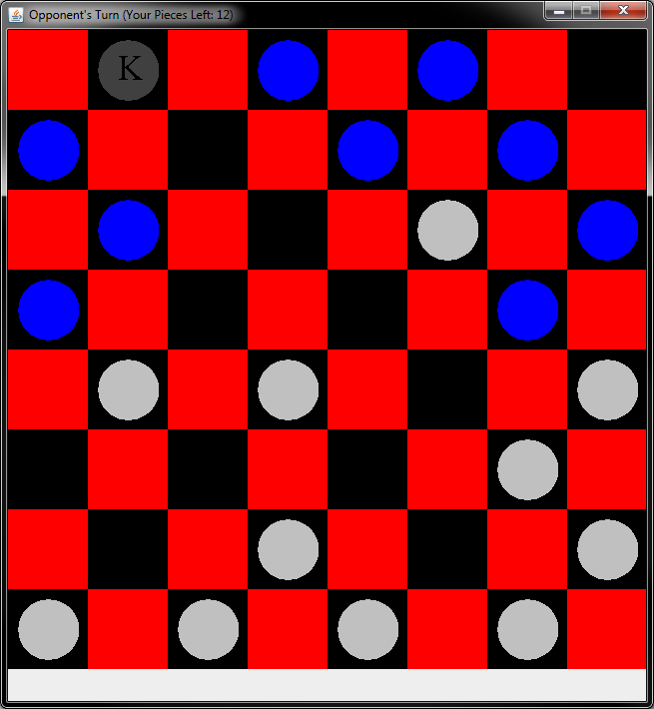

* After a long game of checkers, you are probably ready to move onto something more meaningful with your life. You click that last blue square!

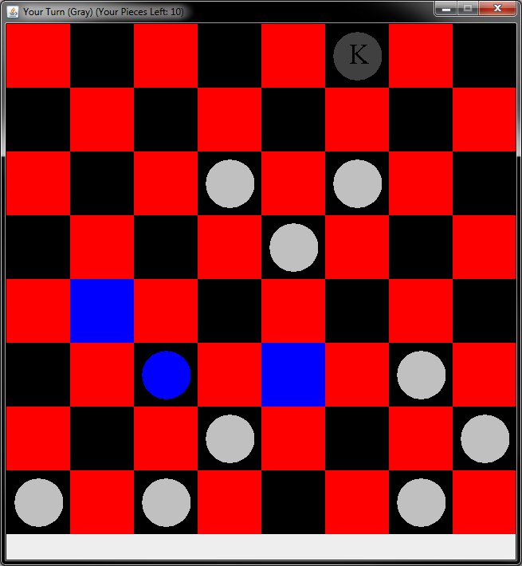

* After all that hard work, what is the prize you ask?!?

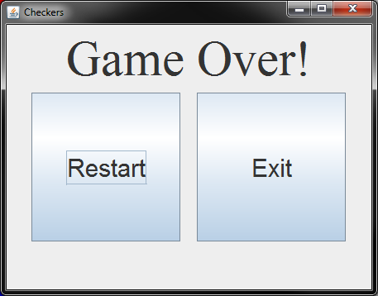

* Will you play again? Or will you exit?? The choice is yours!

The Game Server

To host the game server yourself is no complicated task. Simply run the file passing in the argument for which network port you would like to host it on. The server will start on the address “localhost” or “127.0.0.1” and you will be greeted with a message that logging has begun. An output is generated every time someone new starts/connects-to a game. There is no interaction needed with the server after starting it.